ENROLLMENT INFORMATION FORM
Patient Name: _ Date of Birth: Sex: M / F
Address: ___________________________ City: _______________ State: ____ Zip code: _________ Apt: ___________
Primary phone (H/C/W): _____________________________ Secondary phone (H/C/W): _____________________
E-mail: ___________________________________________
Emergency Contact: _________________________________ Relationship: __________________
Address: ______________________________________ ____ Phone: _______________________
*Please provide copy of insurance card & Driver’s License

Referring Physician: _____________________________ Primary Physician: __________________________
Phone: __________________ Fax: _________________ Phone: ____________________ Fax: ___________________

Insurance Name: ID #: _____________________ Group #: ______________

SSN: ______________________________________

Policy Holder’s Name: ________________________

Relationship to Patient: ________________________ Date of Birth:___________________

Secondary Insurance: ____________________ ID #: _____________________ Group #: ______________

Worker’s compensation patients only
Employer Name: ______________________________________________________________________________
Phone: _______________________________________________ Fax: __________________________________
Address: ______________________________________________ Claim # _______________________________
Case Manager Name: ____________________________________ Phone: ________________________________

I authorize any insurance carrier, employer, hospital or physician to release any information requested regarding my current physical condition. This authorization shall remain in effect until my course of treatment is completed or it is revoked by me in writing. A photocopy of this is to be considered as valid as the original.
Patient Signature/Responsible Party:
Signature: _________________________ Date: _____________________

CONSENT FOR TREATMENT
I am fully aware of my diagnosis and prognosis and I give my consent to treatment by Libre Physical Therapy.
FINANCIAL AGREEMENT
I hereby assign all medical benefits, including major medical benefits, to which I am entitled including Medicare, private insurance and other health plans or insurance coverage to Libre Physical Therapy, including any settlements from lawsuits. I understand that verification of insurance benefits is not guarantee of payment. I am responsible for the account is assigned to an attorney for collections and/or lawsuit, Libre Physical Therapy., will be entitled to reasonable attorney’s fees and cost of collections. I authorize disclosure of portions of the patient’s medical/financial record to the extent necessary to determine liability of payment and to obtain reimbursement. I understand that I am financially responsible for all charges whether or not they are paid by said insurance. I authorize Libre Physical Therapy., to release all information necessary to secure payment.
CANCELLATION POLICY
I understand that it is my responsibility to keep scheduled appointments. Failure to cancel with 24-hour notice will result in a $25 cancellation fee.
*Three consecutive cancellations will result in removal from the schedule without notice.

Consent, Use, Disclosure and Acknowledgment of Healthcare and Privacy Practices
I have had full opportunity to read and consider the contents of the Consent form and the posted Notice of Privacy Practices. I understand that by signing this form I am giving my consent to use and disclose my protected health information to carry out treatment and payment activities concerning my account.

FINANCIAL POLICY AND INSURANCE VERIFICATION
Please take a moment to read the following information about your plan’s PT / OT benefits. Your insurance benefits were verified on ____ /____ /____.
We spoke to your insurance company ___________________________________, who informed us that approved charges would be considered at _________% after you have satisfied a $ ________ deductible. According to your insurance company, this deductible HAS / HAS NOT been met. If your deductible has not been met, we will collect a portion of the payment for each visit towards the allowed amount.
- Your insurance company allows _______ visits for PT/OT, you have _______ visits remaining therefore every visit beyond that you will be responsible for the full amount.
- Medicare monitors patient for medical necessity and will NOT cover any visits beyond medically necessary and/or any visits that are deemed for routine maintenance.
It is our policy to collect your $_________ co-payment or deductible at the beginning of each visit when you check in at the front desk.
After insurance claims have been processed, you will be responsible for any balances due on approved charges or non-covered services,
***Please note that this is not a guarantee of benefits, this is what was reported to us, by your insurance company on the above date***

_______________________________________ __________________
Patient/Parent/Legal Guardian Signature Date

Name: _____________________________ Date: ________________
At LIBRE THERAPY SERVICES, our goal is to provide you with the most complete, personalized care. In order to do so, we ask that you fill out this medical history questionnaire.
Current Condition Overview
Current medical problem/reason for today’s visit: ___________________________________________________________________
Date of onset for this injury/condition: ________________________ Have you had imaging? □ None □ MRI □ X-ray □ CT scan
Please list imaging results: ______________________________________________________________________________________
Have you had surgery for this? □ Yes □ No If applicable, date and type of surgery: ________________________________________
Please list all past surgeries: _____________________________________________________________________________________
Have you had previous PT or OT for this? □ Yes □ No Where? ______________________________________________________
Do you have a history of any of the following?
High Blood Pressure □ Yes □ No Osteoporosis □ Yes □ No Depression □ Yes □ No
Angina/Chest Pain □ Yes □ No Arthritis □ Yes □ No Latex allergy? □ Yes □No Heart Disease □ Yes □ No Cancer □ Yes □ No List any allergies:
Stroke □ Yes □ No Hepatitis/HIV □ Yes □ No ________________________
Kidney Disease □ Yes □ No Seizures □ Yes □ No ________________________
Diabetes □ Yes □ No Headaches □ Yes □ No ________________________
In the past 3 months, have you experienced any of the following?
Change in your health □ Yes □ No Nausea/vomiting □ Yes □ No
Shortness of breath □ Yes □ No Urinary Tract Infection □ Yes □ No
Dizziness □ Yes □ No Upper Respiratory Infection □ Yes □ No
Fever/chills/sweats □ Yes □ No Unexplained weight change □ Yes □ No
Numbness/tingling □ Yes □ No Change in appetite □ Yes □ No
Weakness □ Yes □ No Change in bowel/bladder □ Yes □ No
If you answered “yes”, please describe: ___________________________________________________________________________
Are you currently pregnant? □ Yes □ No | Do you drink alcohol regularly? □ Yes □ No
Do you smoke tobacco? □ Yes □ No | If yes, _____ packs per day for _____ years. Last tobacco use: _____________
Have you had 2 or more falls in the past year, or any fall with injury in the past year? □ Yes □ No

Weight: ________ Height: ________ Calculated BMI (to be completed by therapist; for internal use only): ________
Please answer the following questions regarding your current condition:
My symptoms are: □ Getting worse □ Staying the same □ Getting better
How are you able to sleep at night? □ Fine □ Moderate difficulty □ Only with medication
I currently have difficulty with the following daily activities as a result of my current condition:
- Standing/Walking □ Sitting □ Getting up from a chair □ Driving
- Bending/Lifting □ Sleeping □ Dressing/Grooming □ Grasping
- Reaching overhead □ Reaching behind back □ Work activities
- Other: ________________________________________________________________________________________________
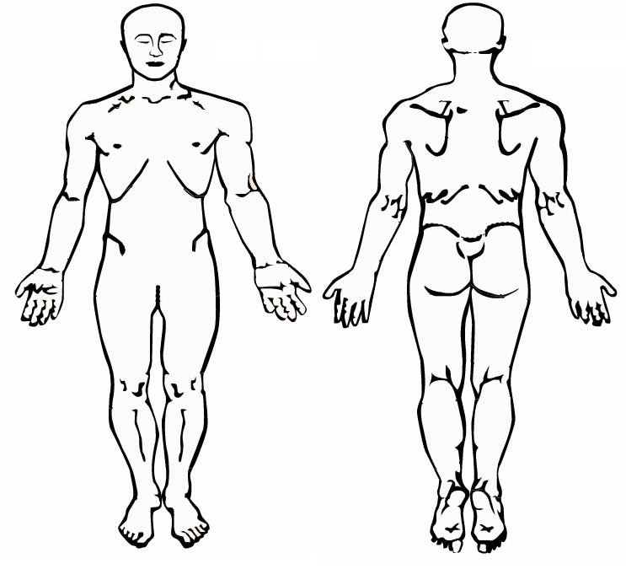Please list all medications, vitamins, and supplements you are currently taking. Please circle the method, list the dosage and circle the frequency by which you take them. If you brought in your medications list today, we will gladly copy it.
SHARP PAIN

ACHINESS

BURNING

NUMBNESS

/ / / / / / / /

O O O O O

+ + +
+
+

Circle your pain on the 0

-10
scale below. 0 is considered

no pain

and 10 is considered the
worst pain imaginable
.

Your pain
now
:

0
------
1
------
2
------
3
------
4
------
5
------
6
------
7
------
8
------
9
------
10

Your pain
at its worst:

0
------
1
------
2
------
3
------
4
------
5
------
6
------
7
------
8
------
9
------
10

Your pain
at its best
:

0
------
1
------
2
------
3
------
4
------
5
------
6
------
7
------
8
------
9
------
10

How would you rate your stress level?
0
------
1
------
2
------
3
------
4
------
5
------
6
------
7
------
8
------
9
------
10

X X X X X

Use the following drawing & symbols shown to indicate the
location

and
type

of symptoms you are experiencing:

Medications, Vitamins,  Supplements | Method (circle one) | Dosage | Frequency (circle one)
 | Oral Patch Inhaler Injection |  | 1x/day 2x/day 3x/day
 | Oral Patch Inhaler Injection |  | 1x/day 2x/day 3x/day
 | Oral Patch Inhaler Injection |  | 1x/day 2x/day 3x/day

